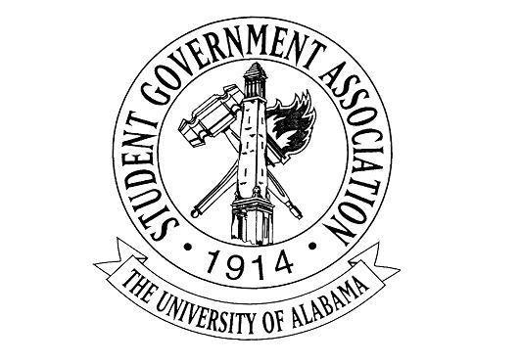
The University of Alabama
Executive Branch
Agenda for October 6th, 2022
- Call to Order
- Attendance Check
- Announcements
- Old Business
- New Business
  - Madeline Martin – President
    - Afternoon at the ArBOOretum
      - October 29 1-4 PM
      - Need volunteers
    - Club Chats
    - Council of Presidents
      - Finalize agenda
      - PowerPoints
    - Better Relations Day
  - Jack Steinmetz – Executive Vice President
    - First FYC meeting was on Tuesday
  - Collier Dobbs – Vice President for External Affairs
    - Battle of the Bands Championship ticket sales will be live tomorrow (10/6) - $10 and available for preorder at slticket.ua.edu.
    - Druid City Music Hall, October 20th 7-11pm
    - We have partnered with the CSL to host a tabling event for service organizations in Tuscaloosa (on and off campus). The event is called “Community Partner Tabling Expo” on October 12th and will be held in the Student Center Plaza from 12pm-2pm
  - Cameron Doyle – Vice President for Academic Affairs
    - Invitations for Gorgas Library Student Artwork Exhibition Reception on October 26th from 4-6 PM
    - Wellness Week Purify U pamphlet distribution will include a handout with an activity schedule
    - Providing a statement from SGA on the new general education proposal
  - Lauryn Parker – Vice President for Financial Affairs
    - October 25th- Financial Wellness Workshop
    - FAC Resource Quick Facts Sheet
    - FAC Q+A
    - Intro to treasurer talks
  - Luke Dille – Vice President for Student Affairs
    - SGA 5K benefiting the Veterans Scholarship Fund
      - October 29th @ 9AM – Please be there!
      - $15 for individual tickets and lower prices for group orders
    - Block Seating – reminder to arrive to student section over an hour early and pick up wristbands
  - Izzy Boyd – Vice President for Diversity, Equity, and Inclusion
    - DEI Passport Program
    - BABH: Food Bank
  - Josie Schmitt – Executive Secretary
    - All FYC and Lobby Board members are now in the ACT Card database
    - Please fill out the google form for the Newsletter
  - Colin Marcum – Chief of Staff
  - Angel Narvaez Lugo – SGA Advisor
- Adjournment

