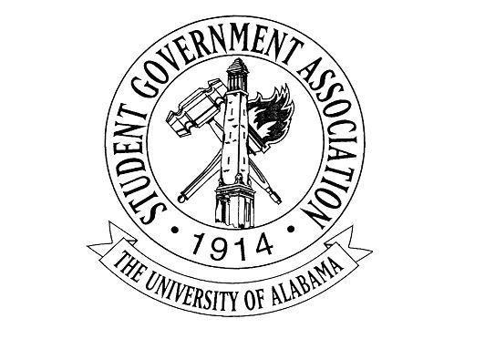
The University of Alabama
Executive Branch
Agenda for October 13th, 2022
- Call to Order
- Attendance Check
- Meghan Haran – Excused
- Carrye Ann Rainer – Excused
- Mary Elizabeth Vincent – Excused
- CJ Pearson – Excused
- Taryn Geiger – Excused
- All other members present
- Announcements
- Old Business
- New Business.
  - Madeline Martin – President
    - Afternoon at the ArBOOretum
      - October 29 1-4 PM
      - Need volunteers
    - Club Chats
    - Council of Presidents
    - Better Relations Day
    - R.E.S.P.E.C.T. Fund
      - Application on the SGA Website
      - Organizations can apply for funding to promote a project or initiative that contributes to health and wellness resources for University students
  - Jack Steinmetz – Executive Vice President
  - Collier Dobbs – Vice President for External Affairs
    - “Community Partners Tabling Expo” was pushed back due to the weather
    - Battle of the Bands Championship will be October 20th at Druid City Music Hall from 7pm-12am
      - Students voted Amberwave, The Wheelers, Poundcake, and Midnight Steel to move on to the Championship round.
      - Tickets can be purchased at sltickets.ua.edu or if your organization is interested in purchasing a discounted bulk ticket package, please email me at jcdobbs@crimson.ua.edu
      - The Career Construction Workshop will be October 27th in the career center. We will be focusing on career development and job preparation as a part of Wellness Week
  - Cameron Doyle – Vice President for Academic Affairs
    - Gorgas Library Student Artwork Exhibition Reception on October 26th from 4-6 PM
    - Distribution of studying locations handout with wellness week schedule
  - Lauryn Parker – Vice President for Financial Affairs
    - Literacy Event October 25th
      - Discount Cards and promotion of student owned businesses
    - FAC Q+A
    - FAC Resource sheets
    - Treasurer Talks
  - Luke Dille – Vice President for Student Affairs
    - SGA 5K benefiting Veteran’s Scholarship Fund
      - October 29th @ 9AM
      - $15 a ticket and we are finalizing group prices for organizations
    - Block Seating – get to block an hour before and utilize complaint form
  - Izzy Boyd – Vice President for Diversity, Equity, and Inclusion
    - BABH Tabling
    - BABH Senate v. FYC
    - Veteran and Military Affairs Office Drive
    - Spiritual Wellness Event
  - Josie Schmitt – Executive Secretary
    - VPs be on the lookout for an email from me asking for a brief description of your day for Wellness Week to be included in the newsletter
  - Colin Marcum – Chief of Staff
  - Austin Heriford – Chief Advisor
  - Meghan Haran – Chief Administrative Officer
  - Claire Dubreuil – Director of Communications
    - Updates on State of the School address?
    - Let me know if you need anything!
  - Carrye Ann Rainer – Director of Engagement
  - Emily Kinsey – Director of Programming & Advancement
  - Andrew Fairburn – Director of Environmental Affairs
    - Saving the Tides Recycling
    - Fall planting at the Arboretum on Sunday
  - Ciara Callicott – Director of Strategic Initiatives
  - Sid Elkins – Director of IT & Webmaster
    - SGA Website
      - New Menu Layout – Coming Monday Oct. 10th
      - New Home Page – Coming Next Week
      - New Page for Senators – TBD
  - David Strickland – Attorney General
    - Updated COL as of 10/6; posted on SGA website
  - Mary Elizabeth Vincent, Reina Parker, & Samad Gillani – Deputy Chiefs of Staff
  - Eric Doh – Treasurer
  - Trinity Hunter – Press Secretary
    - Let me know if you have any suggestions of who you would like us to reach out to concerning programming!
      - Press releases, audio news releases, more campus partners!
  - CJ Pearson – Speaker of the Senate
  - Taryn Geiger – Secretary of the Senate
  - Caleb Thome – Chief Justice
  - Angel Narvaez Lugo – SGA Advisor
- Adjournment

