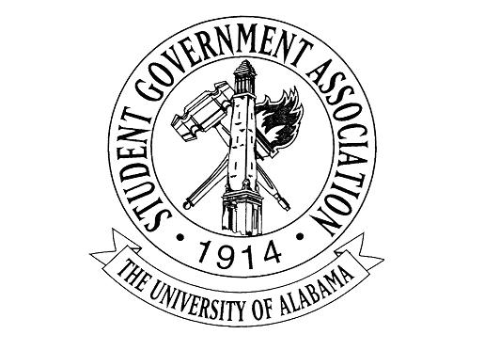
The University of Alabama
Executive Branch
Agenda for September 1st, 2022

- Call to Order
- Attendance Check
  - Carrye Ann Rainer, Absent; Excused
  - Sid Elkins, Absent; Excused
  - Ciara Callicott, Absent; Excused
  - CJ Pearson, Absent; Excused
  - All other members present
- Announcements
- Old Business
- New Business
  - Madeline Martin – President
    - Lunch with the President: Rolling out next Monday
    - Microsoft Teams x Planner
    - Mental Health Guide
    - Turning Tide
  - Jack Steinmetz – Executive Vice President
  - Collier Dobbs – Vice President for External Affairs
    - Lobby Board Applications Close Next Week, September 7th
    - Battle of the Bands Round 1 will be held over social media September 5th-8th. We will put out graphics tomorrow, along with the timeline for all three rounds.
    - Tickets for Battle of the Bands Round 2 will be available September 9th. As of right now, we are planning to sell tickets for $10.

  - Cameron Doyle – Vice President for Academic Affairs
    - The Academic Resource Guide for Fall 2022 will be released next week.
    - Please note that national news sources are available through the UA library database.
    - OIT will host a Microsoft Teams and OneDrive Workshop for the SGA executive branch on Thursday, September 15 at 4-4:45 PM. Location is still being confirmed.
  - Lauryn Parker – Vice President for Financial Affairs
    - Financial Literacy Budgeting Event
      - September 13th
    - First FAC deadline is approaching on September 11th
    - October Literacy Event - Working with Academic Affairs
  - Luke Dille – Vice President for Student Affairs
    - Rotating Blocks every week
    - Halloween 5K for Veterans
  - Izzy Boyd – Vice President for Diversity, Equity, and Inclusion
    - DEI Passport Program
    - CrossingPoints Partnership
    - 9/11 Remembrance
  - Josie Schmitt – Executive Secretary
    - External Office Hour Form and Office Hour Corrections on SGA Website in Qualtrics form
        - Please remind your cabinets about these two links, under Resources -> Member Resources
  - Colin Marcum – Chief of Staff
  - Austin Heriford – Chief Advisor
  - Meghan Haran – Chief Administrative Officer
    - Finalized Directory is posted on the website, please be sure to tell your cabinets if they need to get in contact with anyone in the executive, legislative or judicial branch to utilize this tool.
      - Under resources --> Member Resources
    - Getting lists from Alex, Caroline, and Alex as soon as FYC and Lobby Board are selected to post their contact information as well
    - Meeting with your CAOs at the beginning of each month for a touch base/ to see if they need anything from me

  - Claire Dubreuil – Director of Communications
    - Working on promoting all initiatives via social media
  - Carrye Ann Rainer – Director of Engagement
    - 2022 Committees application now open!
  - Emily Kinsey – Director of Programming & Advancement
    - Fan of the Week
  - Andrew Fairburn – Director of Environmental Affairs
  - Ciara Callicott – Director of Strategic Initiatives
    - Hunger Free College Coalition Updates
  - Sid Elkins – Director of IT & Webmaster
    - New Website Layout!
    - New Layout User Guide
  - David Strickland – Attorney General
  - Mary Elizabeth Vincent, Reina Parker, & Samad Gillani – Deputy Chiefs of Staff
  - Eric Doh – Treasurer
    - First FAC Deadline and Meeting
  - Trinity Hunter – Press Secretary
    - Let me know if you have any questions or concerns about press-related items
    - Check out the press clips I sent y’all today in GroupMe
  - CJ Pearson – Speaker of the Senate
  - Taryn Geiger – Secretary of the Senate
  - Caleb Thome – Chief Justice
  - Angel Narvaez Lugo – SGA Advisor
- Adjournment

