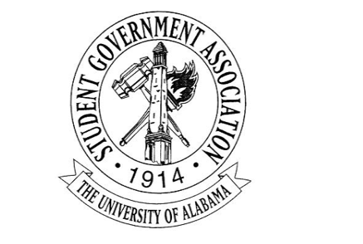
The University of Alabama
Executive Branch
Agenda for September 8th, 2022
- Call to Order
- Attendance Check
- Announcements
- Old Business
- New Business
  - Madeline Martin – President
    - Headshot Photo Booth
      - Rolling out I believe this week
    - Lunch with the President
      - Started this week and will continue through the semester
    - Working with Stillman College to have a Better Relations Day
      - Hopefully end of the semester or early next year
    - SGA Wellness Week
  - Jack Steinmetz – Executive Vice President
  - Collier Dobbs – Vice President for External Affairs
  - Cameron Doyle – Vice President for Academic Affairs
    - The Fall 2022 Academic Resource Guide will be posted tomorrow. Please repost and help spread the word. Thank you!
    - The OIT Workshop for the Executive Branch is on September 15th at 4:15 PM. This event is open to all executive cabinet members, so please encourage your cabinet members to attend to learn about Microsoft Teams, including Planner, and OneDrive.
  - Lauryn Parker – Vice President for Financial Affairs
    - Literacy Event September 13th!
      - There will be a resource guide for budgeting and investing apps that we will passing out at the event!
    - Literacy Event in October- Wellness week!
      - Working with Academic Affairs Cabinet!
    - FAC funding deadline approaching- September 11th!
  - Luke Dille – Vice President for Student Affairs
    - Block Seating and Rotating Blocks
    - Halloween 5K for veterans is a possibility but not a certainty
  - Izzy Boyd – Vice President for Diversity, Equity, and Inclusion
    - CrossingPoints Partnership
    - DEI Passport Program
    - Menstrual Product Drive and Women’s Health Pannel
  - Josie Schmitt – Executive Secretary
  - Colin Marcum – Chief of Staff
  - Angel Narvaez Lugo – SGA Advisor
- Adjournment

