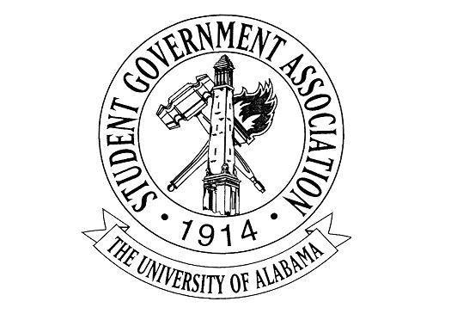
The University of Alabama
Executive Branch
Agenda for September 15th, 2022

- Call to Order
- Attendance Check
  - Jack Steinmetz, Absent; Excused
  - Carrye Ann Rainer, Absent; Excused
  - Austin Heriford, Absent; Excused
  - Sid Elkins, Absent; Excused
  - Taryn Geiger, Absent; Excused
- Announcements
- Old Business
- New Business.
  - Madeline Martin – President
    - Club Chats went out this week.
    - We will be planting our winter produce here soon at the Arboretum.
    - Committees should be promoted and used for any project
  - Jack Steinmetz – Executive Vice President
    - FYC applications have officially closed. Interviews begin next week.
    - Be sure to fill out the survey if you are conducting interviews.
  - Collier Dobbs – Vice President for External Affairs
    - Lobby Board was selected on Tuesday, and we had our first meeting on Wednesday.
    - Battle of the Bands round 2 tickets are live and if y’all have any ideas for marketing outside of social media, please let me know.
    - Voting Matters Week is next week, September 19th-23rd. Lobby Board will be tabling throughout the week around campus, advocating for voter registration and teaching students how to sign up for the first time or register to vote in Alabama.
    - The Keynote Event of Voting Matters Week is “Meet the Mayors” on September 20th at 6pm in the Student Center Theatre (Room 2300). Nine mayors from the surrounding counties will be speaking in a panel discussion regarding civic engagement, voting at a local, state, and national level, along with what their duties as mayor entail and how they got there. We will have a VIP reception after in the Great Hall from 7-8 with food, drinks, and the opportunity to talk to all these mayors one-on-one.
  - Cameron Doyle – Vice President for Academic Affairs
    - Thank you to everyone who came to the OIT workshop!
    - The Academic Resource Guide and Study Abroad Tips were posted this week. Shoutout to Claire for being amazing!
    - Reminder to the executive council that the Bruno Library Opening is tomorrow.
  - Lauryn Parker – Vice President for Financial Affairs
    - September Literacy Event
      - Key takeaways!
    - October Literacy Event
      - Starting to get details finalized
    - FAC Funding
      - Requests are in and applications will be reviewed soon
    - Extra pamphlets to give out!
  - Luke Dille – Vice President for Student Affairs
    - Reminder to get to the block at least 1 hour early on gameday
  - Izzy Boyd – Vice President for Diversity, Equity, and Inclusion
    - Hispanic Heritage Month: SGA X Hispanic-Latino Association
    - Women’s Health Equity Panel: Ignite at UA Partnership (September 22nd)
    - DEI Passport Program
    - BABH Partnership
  - Josie Schmitt – Executive Secretary
    - Planning to get Lobby Board members integrated into ACT card database system next week!
  - Colin Marcum – Chief of Staff
  - Austin Heriford – Chief Advisor
  - Meghan Haran – Chief Administrative Officer
    - New class of the Lobby Board has been added to the directory, just sent to Sid to update on the website
    - Meeting with your CAOs has been going great, I talked with Angel last week and my deputies and I are going to start meeting with the directors of your cabinets to see what they need help with
    - Working on new office stationery for thank you cards, informal letters etc.
    - Cabinet Appreciation Week is in the works, looking at one of the first weeks of October and having a few fun things around the office/appreciative gestures for them that week
    - Want to network positions together across different cabinets; ex: all VPs Directors of communication meet each other and can reach out to one another for a second opinion
  - Claire Dubreuil – Director of Communications
    - Working on promoting all initiatives
    - Let me know if you need photographers at any of your events!
  - Carrye Ann Rainer – Director of Engagement
  - Emily Kinsey – Director of Programming & Advancement
    - Encourage your friends to submit for Fan of the Week
    - Partnering with Alabama Alumni Association
    - If you need any help with your programming, please reach out!
  - Andrew Fairburn – Director of Environmental Affairs
    - Going to the arboretum next Wednesday @5 pm for anyone who wants to join
  - Ciara Callicott – Director of Strategic Initiatives
    - Coalition Meeting this Sunday
    - Looping in Lobby Board
    - Hunger Action Day
  - Sid Elkins – Director of IT & Webmaster
  - David Strickland – Attorney General
  - Mary Elizabeth Vincent, Reina Parker, & Samad Gillani – Deputy Chiefs of Staff
  - Eric Doh – Treasurer
  - Trinity Hunter – Press Secretary
    - Keep submitting things in a timely manner <3 about your programming and any initiatives
  - CJ Pearson – Speaker of the Senate
    - Good Samaritan Drug Overdose Training Program
    - Stomp Out Hunger
    - Committee Process Overview
  - Taryn Geiger – Secretary of the Senate
  - Caleb Thome – Chief Justice
  - Angel Narvaez Lugo – SGA Advisor
- Adjournment

