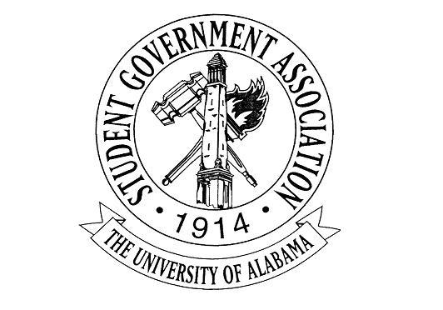

The University of Alabama
22nd Student Senate 2017-2018
Agenda for November 16th, 2017
Regular Session

- Call to Order and Roll Call

- Recitation of the SGA Mission statement and the Capstone Creed by Senator Harrington and Senator Veje

- Announcements: Senate Meet and Greet this Friday November 17th from 1-3pm (counts as 2 office hours). Sign up for the powderpuff game! Final Senate meeting of the semester is Nov. 30th

- Report on the Feasibility of Free or Reduced Cost STI Testing -- VP Charlie Steinmetz and VP Mollie Gillis

- Break for Committees

- New Business:
  - A-14: AN ACT TO BEGIN TRIAL “COME SEE FYC” STATIONS ACROSS CAMPUS First Year Councilor Caitlyn Johnson

- Old Business:
  - A MOTION TO DISCHARGE A-13: S.A.F.E. ACT OF 2017 made by Senator Emma Thomas (properly seconded)

- Adjourn

ACT A-14-17
THE UNIVERSITY OF ALABAMA
22nd SENATE 2017-2018

AN ACT TO BEGIN TRIAL “COME SEE FYC” STATIONS ACROSS CAMPUS

Authored by: First Year Councilor Caitlyn Johnson
Sponsored by: Senator Kelsey Montgomery

Section 1: If enacted, this act will allow the FYC to begin holding “Come See FYC” stations across campus (similar to “Say Hey SGA” stations currently held by the SGA body as a whole).

Section 2: Tuesday and Wednesday, December 5th & 6th, will be considered a “trial phase” of the program in which every member has the opportunity to participate and determine if it is truly effective.

Section 3: Every member of FYC is required to log at least 2 hours at a Come See FYC station, however these 2 hours will also be recognized as office hours (pending approval of the Executive Secretary).

Section 4: Representatives from each residence hall will choose a place they feel reaches the most of their constituents and set up a station there to talk and hand out stickers and contact information to freshman students.

Section 5: The First Year Council requests:
- A budget of $350 for supplies to encourage students to stop and discuss their experiences on campus.
  - Examples of supplies could include:
    - Paper/ink to print flyers with representatives’ contact information
    - Stickers (Cost ultimately dependent upon designs, but 2,000 stickers can cost anywhere from $200-$300)
    - Any leftover money will be used for candy or other treats to encourage freshmen to stop and discuss their time at UA

Section 6: After the event, the First Year Council as a whole can discuss the effectiveness of the “Come See FYC” program. If it is seen to be effective, a new act would be drawn up to outline how the program would be continued throughout the rest of our term as councillors.

Section 7: A request will be submitted to Panhellenic to allow 1 Greek Point to be granted to freshmen who find the contact information of their Councilor and send them an email introducing themselves and telling their representative how their experience has been so far at UA. Councilors will have a shared Google Doc where names of constituents who do this will be added and the list will ultimately be sent to Panhellenic.

Section 8: A Project Approval Form will be submitted to the Chief Administrative Officer upon passage.

ACT A-13-17
THE UNIVERSITY OF ALABAMA
22nd SENATE 2017-2018

Authors: Vice President Ross D’Entremont, Senator Emma Thomas
Sponsors: Senator Rob Harrington, Senator Hannah Echols, Senator Katie Judson, Senator Lauren Griffith, Senator Sarah Boudoin, Senator Mary Elizabeth Clements, Senator Chris Hannigan, Senator Eric Silver, Senator Daniela Bishop, Senator Sarah Michel, Senator Harrison Adams, Senator Talor Allen
Endorsements:
S.A.F.E. Act of 2017

Section 1. Findings of Vice President D’Entremont and Senator Thomas:

- It has become apparent that sexual assault is a prevalent issue on college campuses nationwide. While there is a growing need for sexual assault awareness and prevention, there is a greater need for sufficient resources and help for victims of sexual assault.
- The Tuscaloosa community is working to bring the Sexual Assault Forensic Examiner program to West Alabama and establish a SAFE Center in the Tuscaloosa Area. This program will be an important resource for students at the University of Alabama as well as the rest of the Tuscaloosa community. The SAFE Center would be an outstanding resource to victims and would help further advocacy for sexual assault awareness in the community.
- There are large upfront costs to bring this center to the Tuscaloosa community and there will be a significant amount of funding needed to sustain the program.
- As representatives of the student body, we should support efforts to raise money to bring this program to the Tuscaloosa area. It is our responsibility to support programs that will be beneficial to the people and communities we represent and serve.
- The SGA, in conjunction with the Panhellenic Association, is hosting a powder puff game to raise money for the program. Different branches of SGA, fraternities and sororities, and other student organizations on campus are being asked to make a $250 contribution and enter a team to participate.

Section 2. Legislation

Therefore be it resolved, that the 2017- 2018 Senate will make a $250 contribution to the fundraising efforts for the Tuscaloosa community SAFE program. In addition to the monetary contribution, the Senate will form a team to participate in the SGA powder puff game as a way to show our support for the event and the SAFE program; and,

Be it further resolved that, all Senators will bring awareness about the SAFE program and the resources that the SAFE Center will offer to all of their constituents; and,

Be it further resolved that copies be sent to the following: President Jared Hunter, Student Government Association; Vice President Ross D’Entremont, Student Government Association; Vice President Charlie Steinmetz, Student Government Association; Mary Lee Caldwell, Student Government Association; and Will Jones, The Crimson White.

