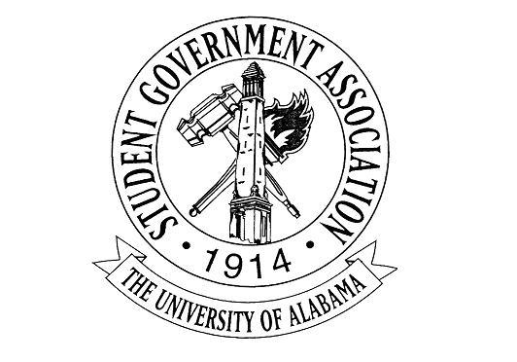

The University of Alabama
22nd Student Senate 2017-2018
Agenda for November 2nd, 2017
Regular Session

- Call to Order and Roll Call

- Recitation of the SGA Mission statement and the Capstone Creed by Senator Heatley and Senator Echols

- Announcements: Senate Meet and Greet on November 10th and November 17th from 1-3pm (counts as 2 office hours), more info to come but mark your calendars for those dates

- Break for committees

- New Business:
  - R-09: A RESOLUTION IN SUPPORT OF WORKING WITH UNIVERSITY HOUSING AND RESIDENTIAL COMMUNITIES AND THE OFFICE OF FRATERNITY AND SORORITY LIFE TO PREVENT OPIOID OVERDOSES Senator Robert E. Pendley (attached in email due to size of file)
  - R-10: A RESOLUTION TO DISCOURAGE THE USE OF STYROFOAM Senator Michael Smith

- Adjourn

RESOLUTION R-10-17
THE UNIVERSITY OF ALABAMA
22nd SENATE 2017-2018

Authored by: Senator Michael Smith
Sponsored by: Senators Marissa Navarro, Rob Harrington, Mason Johnston, and Cara Clay

A RESOLUTION TO DISCOURAGE THE USE OF STYROFOAM

Be it enacted by the Senate of the Student Government Association assembled.

WHEREAS, Styrofoam, and its basic building block of Styrene, is classified as a possible human carcinogen; and

WHEREAS, the process of making Styrofoam pollutes the air and creates large amounts of liquid and solid waste; and

WHEREAS, Styrofoam products are made with petroleum, a
non-sustainable and heavily polluting resource; and

WHEREAS, at the end of its use, Styrofoam is often dumped into the environment as litter and, unless broken down by living beings, does not biodegrade for hundreds to potentially millions of years; and

WHEREAS, an article published in Science Magazine by researcher Henry Wells from the University of Minnesota shows a strong improvement in the recyclability and environmental impact of switching from Styrofoam to paper products, specifically with regard to disposable cups^{[1]}; and

WHEREAS, Auburn University has implemented a successful program to incentivize the use of paper products in their Dining Services to completely replace Styrofoam items at a cost of only 18 cents per student^{[2]}.

Therefore, be it resolved, that The Senate of the Student Government Association encourages the University of Alabama to continue decreasing its use of Styrofoam items and similar products.

Be it further resolved, that the Senate of the Student Government Association encourages the University of Alabama to follow the lead of many of universities, including Auburn University, in taking steps to make Alabama’s campus styrofoam free within the next 3-5 years.

Be it further resolved, that the Senate of the Student Government Association encourages the University of Alabama specifically to incentivize on-campus companies to switch from polystyrene to paper products by subsidizing the difference in costs between Styrofoam and alternate material items.

Be it further resolved, that copies of this Resolution shall be distributed to the following: Dr. Stuart Bell, President of the University of Alabama; Jared Hunter, SGA President; Elizabeth Elkin, Editor-in-Chief of The Crimson White; Teresa Shreve, Assistant Vice President for Enterprise Operations; Kristina Patridge, Director of University Dining Services.

^{[1]} Wells, H. A., Jr. (1991, June 7). Paper Versus Polystyrene: Environmental Impact. Science, 252(5011), 1361.
^{[2]} Ross, L. (2014, September 15). Auburn University becomes Styrofoam free. Retrieved October 30, 2017, from http://ocm.auburn.edu/newsroom/ news_articles/2014/09/auburn-university-becomes-styrofoam-free.htm

