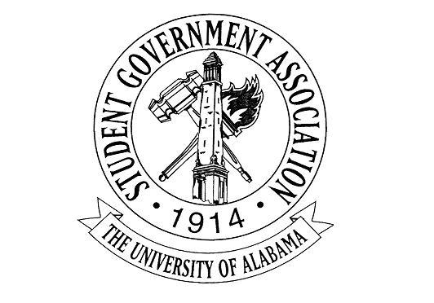

The University of Alabama
22nd Student Senate 2017-2018
Agenda for September 14th, 2017
Regular Session

- Call to Order and Roll Call

- Recitation of the SGA Mission statement and the Capstone Creed by Senator Thurston and Senator Echols

- Announcements:

- Break for committees

- Old Business: No Old Business

- New Business
- R-06: A RESOLUTION CONGRATULATING THE SCHOOL OF SOCIAL WORK ON THE COMPLETION OF LITTLE HALL Senator McQueen and Senator Judson
- B-03: A BILL TO IMPROVE PROCEDURAL INTEGRITY Senator Clay Gaddis
- A-07: AN ACT TO APPROVE THE ORGANIZATIONAL FUNDING REQUESTS SUGGESTED BY THE FINANCIAL AFFAIRS COMMITTEE FOR THE MONTH OF SEPTEMBER 2017, AND FOR OTHER PURPOSES VPFA Charlie Steinmetz
- Adjourn

RESOLUTION R-06-17
The University of Alabama
22nd Student Senate 2017-2018

Co-authored by: Darby McQueen and Katie Judson

A RESOLUTION CONGRATULATING THE SCHOOL OF SOCIAL WORK ON THE COMPLETION OF LITTLE HALL

WHEREAS, Little Hall has an interesting history of being a gymnasium in 1915 and named after William “Bill” Gray Little, a transfer student who played Alabama football; and

WHEREAS, Little was the home of the School of Nursing after its renovation in 1935; and

WHEREAS, the School of Social Work became a University of Alabama recognized program in 1967; and

WHEREAS, the program was accredited in 1974; and

WHEREAS, Little Hall finally became the home of the School of Social Work in 1967; and

WHEREAS, In Spring of 2016 Little Hall went under construction and was finally completed in the summer of 2017; and

THEREFORE, BE IT RESOLVED, that the Senate of the Student Government Association congratulates the School of Social Work on the completion of Little Hall.

BE IT FURTHER RESOLVED, the copies of this Resolution will be sent to the following: Crimson White, Dr. Vikki L. Vandiver, Dean of Social Work, Dr. Laura Hopson, Associate Professor and Director of BSW Program, Dr. Javonda Williams, Associate Dean of Educational Programs And Student Services.

BILL B-03-17
The University of Alabama
22nd SGA Senate 2017-2018

Author(s): Senator Clay Gaddis
Sponsor(s): Senators Matthew Childress, Molly Stalter, and Robert Pendley
Endorsement(s): Senate Parliamentarian Colin Bennett

A Bill to Improve Procedural Integrity

Section 1. Findings:
A. Most Senate resolutions in the past session did not make it to committee due to the rules being immediately considered upon the first reading.
B. Nearly all Senate resolutions are passed without dissent from the voting body.
C. Senate Rules and Regulations Chapter 400.3.4 : “Resolutions which encourage specific actions will be considered non-binding, unless the encouraged action was an initiative to be undertaken exclusively by the Senate.”
D. Immediate consideration of a resolution requires a motion to Suspend the Rules, which is a powerful procedure that should, ideally, be used only in odd circumstances. The frequent use of this motion threatens the integrity of the Senate standing rules.
E. The Senate’s currently accepted procedure to immediately consider a motion is regarded as informal and improper by the Parliamentarian of the Senate.
F. Motions which should normally be committed, such as Acts compelling the action of the entire Student Government Association, have been immediately considered because of this dangerous trend away from committee involvement.
G. Debating and amending resolutions upon first reading will encourage overall Senator participation during meetings.

Section 2. Legislation
Chapter 400.3.9 Resolutions shall not be subject to automatic committee referral by the Speaker of the Senate and may be immediately considered following the first reading. This shall not be true for resolutions including financial allocations.

And strike the words, “under the suspension of the rules.” From Chapter 401.1 of the Senate Rules and Regulations which would read:
“Chapter 401.1 No amendments may be considered until its referral to a committee, or if the legislation is immediately considered under the suspension of the rules”

Therefore, be it resolved that copies be sent to the following upon this Bill being signed by the President, or otherwise becoming law:
Attorney General Lance McCaskey, SGA President Jared Hunter, and The Crimson White Media Group

ACT A-07-17
THE UNIVERSITY OF ALABAMA
22nd SENATE 2017-2018

Authored by: Vice President of Financial Affairs Charlie Steinmetz
Sponsored by: Senator Eric Silver

AN ACT TO APPROVE THE ORGANIZATIONAL FUNDING REQUESTS SUGGESTED BY THE FINANCIAL AFFAIRS COMMITTEE FOR THE MONTH OF SEPTEMBER 2017, AND FOR OTHER PURPOSES

WHEREAS, The Senate finds the following:
a. The Financial Affairs Committee met on September 12th, 2017.
b. The committee heard the funding requests of Twenty – Nine various organizations before making its decisions.

THEREFORE BE IT RESOLVED, The Senate approves the following FAC funding requests in the amounts for a total of $23,103.00 listed in the excel sheet attached:

BE IT FURTHER RESOLVED, copies of this resolution shall be sent to Jared Hunter, SGA President; Charlie Steinmetz, SGA Vice President for Financial Affairs; Sherry Phillips, FAC Advisor; and The Crimson White; and others as may be deemed necessary at a later date.

