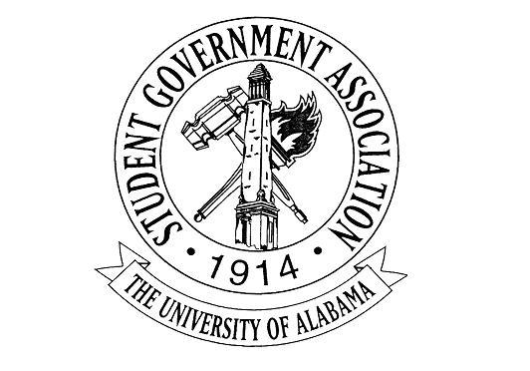

The University of Alabama
22nd Student Senate 2017-2018
Agenda for February 1st, 2018
Regular Session

- Call to Order and Roll Call

- Recitation of the SGA Mission statement and the Capstone Creed by Senator Heatley and Senator Smith

- Announcements:

- Break for committees

- New Business:
  - R-16: A RESOLUTION IN SUPPORT OF EXPANDING CAMPUS FOOD PANTRY Senator Marissa Alayna Navarro
  - R-17: A RESOLUTION TO SUPPORT DACAMENTED STUDENTS, AS WELL AS THE CONTINUATION OF THE DEFERRED ACTION FOR CHILDHOOD ARRIVALS (DACA) PROGRAM Senator Marissa Alayna Navarro

- Adjourn

Resolution R-16-18
The University of Alabama
22nd Student Senate 2017-2018
Authors: Senator Marissa Alayna Navarro
Co-Sponsors: Sen. Daniela Bishop, Sen. Cara Clay, Sen. Parnab Das, Sen. Mitch Doran, Sen. Katie Judson, Sen. Baily Martin, Sen. Darby Mcqueen, Sen. Kelsey Montgomery, Sen. Harrison Smoak
A RESOLUTION IN SUPPORT OF EXPANDING CAMPUS FOOD PANTRY
WHEREAS, hunger and food insecurity are serious problems in our community; and
WHEREAS, food insecurity is defined as a situation where consistent access to adequate food is limited by a lack of money and other resources; and
WHEREAS, as a college education becomes increasingly expensive, more students are being forced to live near or below the poverty level; and
WHEREAS , college students often have limited transportation options and community-based food resources are typically not located close to campuses; and,
WHEREAS , college students, while food insecure, might not meet community-based agency requirements and/or may be uncomfortable in accessing services off campus; and,
WHEREAS , food insecurity cuts across all demographic statuses, enrollment levels, and geographic locations; and,
WHEREAS , as a campus community, we have a responsibility to help students who are in need of assistance; and,
WHEREAS, currently there is a meal donation program located within the Dean of Students Office and Student Care and Well Being for students who are food insecure; and
THEREFORE, BE IT RESOLVED THAT, that The University of Alabama Student Government Association supports the expansion of a campus food pantry at The University of Alabama; and
BE IT FURTHER RESOLVED, that The University of Alabama Student Government Association commits to providing support by promoting and assisting with food drives; and
BE IT FINALLY RESOLVED THAT , copies of this resolution be sent to the following: Dr. Stuart Bell, President of the University of Alabama; Dr. Ruperto Perez, Associate Vice President of Student Health and Well-Being; Shannon Hubbard, Coordinator, Alabama REACH, Casey Nelson, 2017-2018 SGA President; Mollie Gillis, 2017-2018 Vice-President of Student Affairs; SGA Lobby Board; the Crimson White Media Group

RESOLUTION R-17-18
The University of Alabama 22nd
Student Senate 2017-2018
Author : Marissa Alayna Navarro
Sponsors : Sen. Salvatore Arena, Sen. Daniela Bishop, Sen. Cara Clay, Sen. Parnab Das, Sen. Clay Gaddis, Sen Katie Judson, Sen. Darby Mcqueen, Sen. Robert Pendley, Sen. Harrison Smoak, Executive Secretary Stephanie Gaytan
A RESOLUTION TO SUPPORT DACAMENTED STUDENTS, AS WELL AS THE CONTINUATION OF THE DEFERRED ACTION FOR CHILDHOOD ARRIVALS (DACA) PROGRAM
WHEREAS, the Deferred Action for Childhood Arrivals program (DACA),
established in 2012, provides eligible undocumented immigrants with the ability to
“apply for temporary deferrals of deportations and [for] work permits”^{[1]}; and
WHEREAS, DACA has enabled more than 700,000 individuals brought to the
United States before their 16th birthday to stay in the United States^{[2]}; and
WHEREAS, some the beneficiaries of this program include students previously or
currently enrolled in postsecondary educational institutions, such as The University
of Alabama; and
WHEREAS, in a recent national survey, conducted in June 2015 to analyze the
impact of DACA, 92% of respondents who were then enrolled in school noted that
DACA allowed them to “pursue educational opportunities [they] previously could
not” have pursued^{[3]}; and
WHEREAS, recently there has been a serious discussion about ending the DACA
program^{[4]}; and
WHEREAS, in light of such discussions, more than 510 other college and
university presidents across the United States signed a letter, which called the need
to uphold and continue the DACA program a “moral imperative” and “national
necessity”^{[5]};
THEREFORE BE IT RESOLVED, that The University of Alabama Student
Government Association joins other higher education student governments in their
call to uphold and continue the DACA program; and
BE IT FURTHER RESOLVED, that The University of Alabama Student
Government Association reaffirms its support of DACAmented students at The
University of Alabama and across the country; and
BE IT FINALLY RESOLVED THAT COPIES BE SENT TO THE FOLLOWING: Dr. Stuart Bell, President of The University of Alabama, President Casey Nelson, Student Government Association; Dr. Ruperto Perez, Associate Vice President of Student Health and Well-Being; Shannon Hubbard, Coordinator, Alabama REACH, Vice President Ross D’Entremont, Student Government Association; Vice President Charlie Steinmetz, Student Government Association; Elizabeth Elkin, Editor-in-Chief of The Crimson White.

^{[1]} https://www.americanprogress.org/issues/immigration/news/2015/07/09/117054/results-from-a-nationwide-survey-of-daca-recipients-illustrate-the-programs-impact/
^{[2]} Ibid. 1.
^{[3]} Ibid. 1.
^{[4]} http://www.nytimes.com/2016/11/20/us/immigrants-donald-trump-daca.html.
^{[5]} https://www.pomona.edu/news/2016/11/21-college-university-presidents-call-us-uphold-and-continue-daca.

